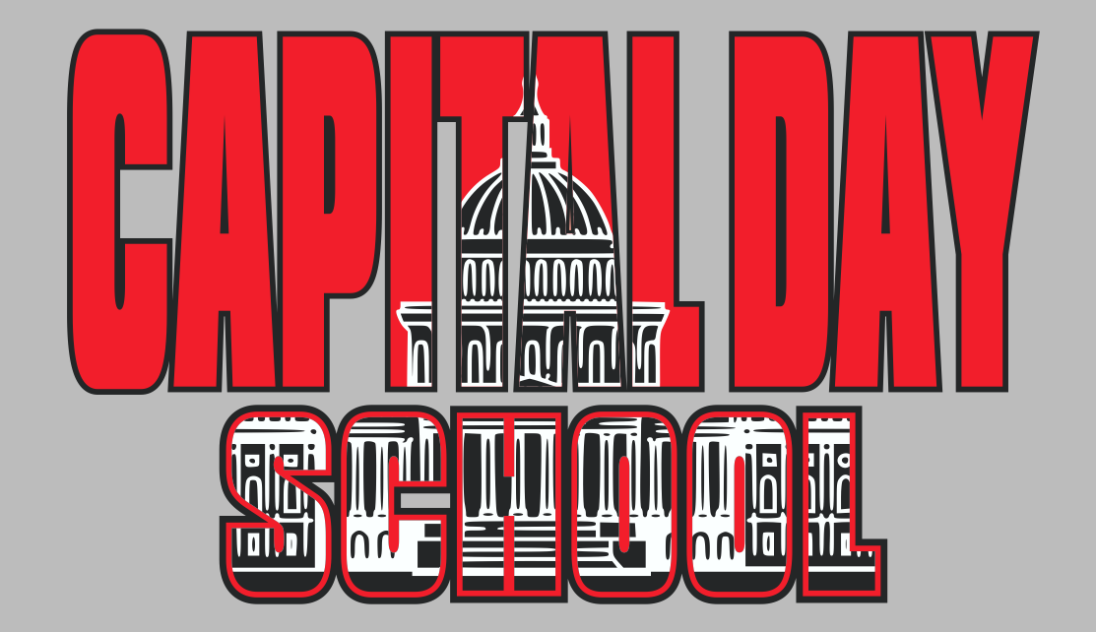
Best Kids Ever! PK-8th Grade
2022-2023 School Calendar

August 5 Last Day of Summer Program
11-12 Professional Development Days for Teachers
16-17 Pre Planning for Teachers
18 First day of Classes for students

September 5 Labor Day – NO SCHOOL
23 Mid-Quarter

October 3-7 Fall Break – NO SCHOOL
21 End of 1st Quarter

November 8 Election Day/All School Parent Teacher Conferences - NO SCHOOL
11 End of 1st Trimester (Preschool)
18 Mid-Quarter

21-25 Thanksgiving Break – NO SCHOOL

December 16 Last Day of Classes
19-31 Holiday Break – NO SCHOOL

January 2 Holiday Break Continued – NO SCHOOL
3 Classes Resume
13 End of 2nd Quarter
16 Martin Luther King, Jr. Day – NO SCHOOL

February 3 End of 2nd Trimester (Preschool)
3 Mid-Quarter
17-20 Winter Break – NO SCHOOL

March 13 Professional Development Day - No School
17 End of 3rd Quarter

April 3-7 Spring Break – NO SCHOOL
17-21 ERB Testing for 3rd-8th grade
21 Mid-Quarter

May TBD Student Appreciation Week/Teacher Appreciation Week
25 Last Day of Classes- Dismissal at Noon
25 8th Grade Graduation

June 5 First Day of Summer Program

